**689A and 689B nm Laser SOP**

10/26/2021

Kolkowitz Group

This SOP describes the correct operation, alignment procedures, and practices with the three Class 3B 689 nm lasers in the Kolkowitz lab (Chamberlin 5264). All lasers are the exact same type and labelled 689A, 689B and 689C.

* **CONTACT INFORMATION**

|  |  |  |  |
| --- | --- | --- | --- |
| **Primary Lab Safety Contact** | Jack Dolde | 515-710-9347 | dolde@wisc.edu |
| **Kolkowitz Lab Safety Officer** | Aedan Gardill | 608-220-4686 | gardill@wisc.edu |

* **LASER DETAILS**

|  |  |  |
| --- | --- | --- |
| **Laser Class:**  3B | **Laser Type and Mode:**  Type: ECDL / Mode: CW | **Wavelength:**  689 nm |
| **Max Power:**  45 mW  33 mW  44 mW | **Model:**  A31708094  A31907010  A31907067 | **Manufacturer:**  MogLabs |

* External Cavity Diode Laser

* **LASER LOCATION**

Laser Located on second optics table.

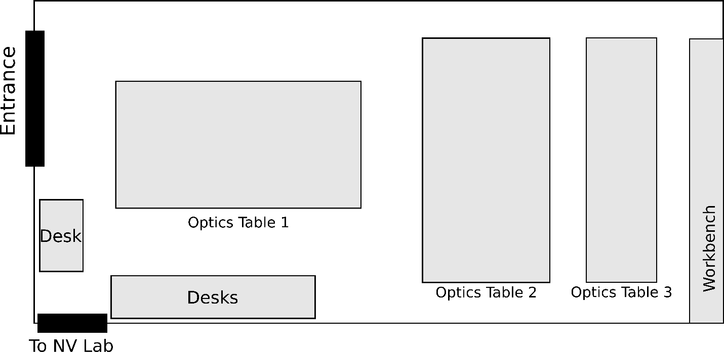

689 nm laser

* **LASER SAFETY GENERAL CAMPUS POLICIES**
  + Responsibilities of the laser operator(s):
    - Operator will ensure the safety of any personnel that might enter the room and will advise same of the status of the lasers and optics. This includes ensuring use of protective eye wear where necessary. The laser user is responsible for the safe of the laser(s) at all times.
    - Incidents/accidents will be reported promptly to EH&S @ (608) 265-5000. Emergency response: 9-1-1
  + **Laser Training Requirements:**
    - *Part 1* *of the training* involves review the EH&S online Laser Safety Training. This is accessible through a module on UW-Madison’s Canvas. (<https://canvas.wisc.edu/enroll/YKPXGJ>) A baseline eye exam must be completed before use of Class 3B and 4 lasers. This eye exam is performed by UW’s University Health Services (333 East Campus Mall).
    - *Part 2* *of the training* is given by the Principal Investigator (PI). The PI is responsible for providing instruction in the safe and appropriate use of the laser related to the specific research project
    - *Laser Registration Requirements:* EH&S must be notified after the purchase any class 3B or 4 lasers through the online Laser Registration Form. Device label(s), door placard(s) and exterior light installed.
    - *Personnel Protective Equipment Requirements:* EHS will review the laser application/SOP. Typically, protective eyewear will be required. Other protective equipment may also be needed. This will be evaluated on a case by case basis. Users are responsible for purchasing and using prescribed protective equipment.
    - *Disposal Requirements:* EHS requires proper disposal of all class 3B and 4 lasers. The laser may contain toxic or hazardous materials which require proper disposal. Use the EHS Laser Disposal Form to begin the disposal process.
* **OPERATING PROCEDURES**
  + Remove jewelry that might reflect beams.
  + Use appropriate eyewear when aligning beams. Be certain it is of appropriate OD for the wavelength(s) in use.
  + Turn on outside warning light.
  + Inspect optical setup for recent changes/and or foreign objects.
  + Verify that all personnel in the lab are wearing approved eyewear.
  + Issue verbal warning prior to starting laser.
  + Power up laser controller.
* **ALIGNMENT PROCEDURES**
  + Special alignment procedures:
    - Use low power alignment laser, when possible.
    - Use lowest possible energy setting.
    - Survey area (with UV/IR viewer, if necessary) for reflections and confine such reflections to the optics table.
  + Only after completing these procedures the laser power shall be increased to desired power. If more than one person is present, announce increase in power so that all present in the vicinity are aware of the change.
  + *Other safety tips:*
    - Allow only trained personnel to be present during alignment. Whenever possible, minimize the number of personnel present. All present must wear appropriate eyewear.
    - If possible, avoid using beam paths that are at sitting or standing eye level.
    - Where feasible, use low power (class 2 or 3A) visible lasers to simulate the path of high power or invisible lasers.
    - Where feasible, terminate laser beams and specular reflections on diffuse reflecting beam blocks.
    - Use phosphor cards, IR viewers, video cameras or other display devices to locate invisible beams.
    - Locate any specular reflections of the beam and block them as close to the source as possible.
    - Whenever possible, reduce all high-power laser beams to the minimum possible power.
    - Use beam shutters to block high power beams any time they are not actually needed.
* **CONTROL MEASURES**
  + Entryway light: light outside of entry door to indicate when laser is on
  + Laser secured to optical table
  + Beam stops/ beam attenuators are used
  + Master key to switch off laser
  + Warning signs are posted outside of lab
  + Equipment manuals available in lab
  + PPE eyewear available for alignment
* **HAZARDS AND CONTROL**
  + Unenclosed beam/ access to direct or scattered light.
* All stray and diffuse beams are blocked by dumps/traps.
  + Beams travel through fibers.
    - Fibers are labeled and well controlled
* **EYEWEAR**
  + The following eyewear is available in the lab, stored on door between lab spaces

|  |  |  |
| --- | --- | --- |
| **Wavelength Attenuated:**  671-715 nm | **Optical Density (OD):**  5+ | **Manufacturer:**  Cascade Laser Corp |

* **OPERATOR REVIEW**

I have read and understood this procedure, its content, the EHS review below and attached addendum(s). I agree to follow this procedure each time I use the laser/laser system. **Please read any addendums to this SOP prior to signing.**

|  |  |  |
| --- | --- | --- |
| **Name** | **Signature** | **Date** |
| Shimon Kolkowitz | S. K. | 10/26/2021 |
| Xin Zheng | X. Z. | 10/26/2021 |
| Jack Dolde | J. D. | 10/26/2021 |
| Hong Ming Lim | H. L. | 10/26/2021 |
| Nico Ranabhat | N. R. | 10/26/2021 |
|  |  |  |
|  |  |  |
|  |  |  |